CPE301 – FALL 2019

Design Assignment 2C

Student Name: Brysen Kokubun

Student #: 2001009068

Student Email: brysenkokubun96@gmail.com

Primary Github address: https://github.com/bkokubun99/Submission_DesignAssignments

Directory:<https://github.com/bkokubun99/Submission_DesignAssignments/tree/master/DesignAssignment_2C>

1. **COMPONENTS LIST AND CONNECTION BLOCK DIAGRAM w/ PINS**

Atmel Studio 7.0 Atmega328PB-Xmini PC Multi-Function Shield Button

- Assembler -LEDs

- Simulator

- Debugger

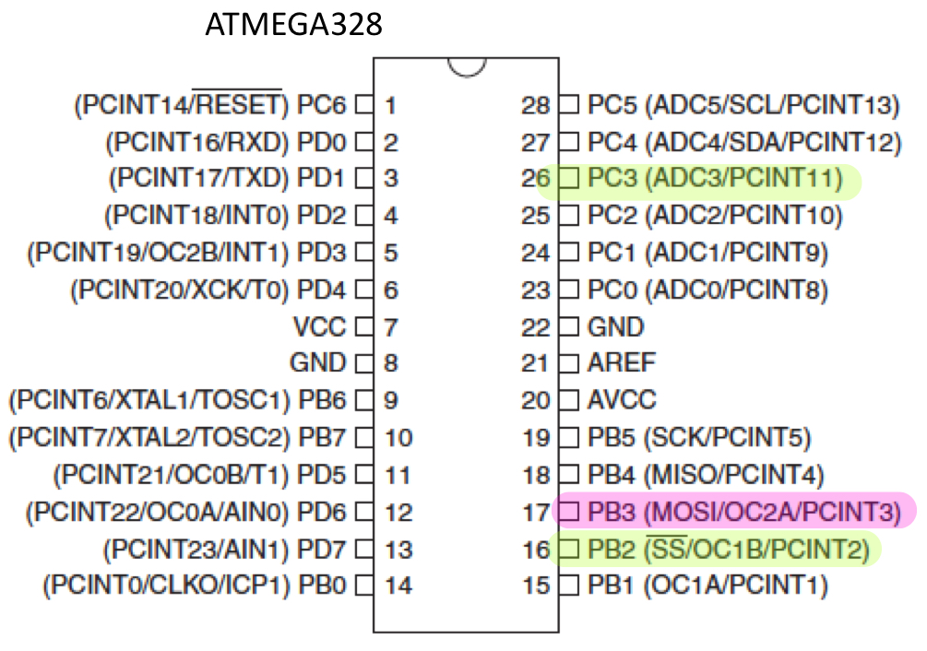

1. **INITIAL/MODIFIED/DEVELOPED CODE OF TASK 1/A**

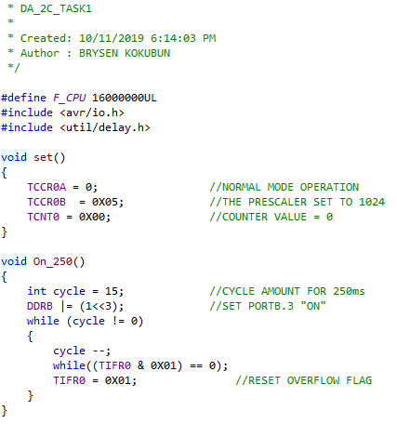

Task 1 Code

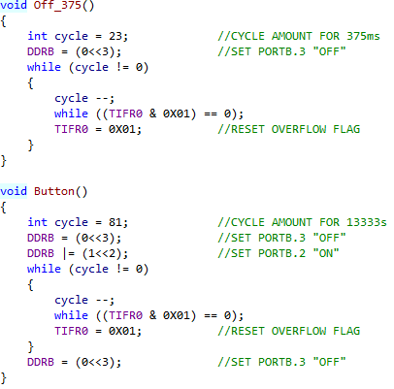

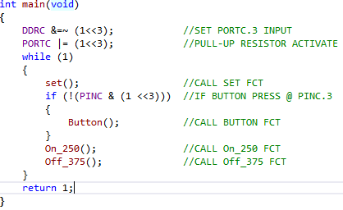

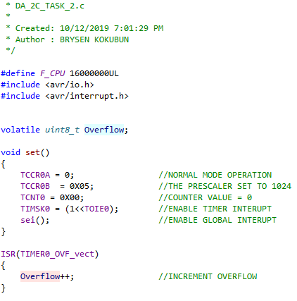

Task 2 Code

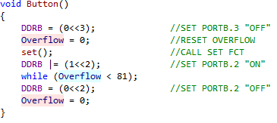

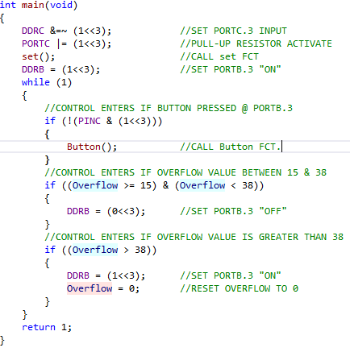

Task 3 Code

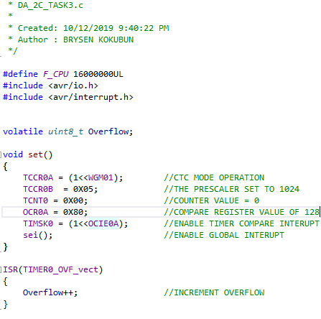

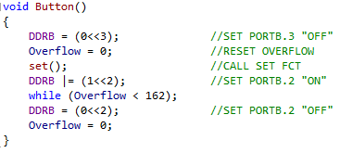

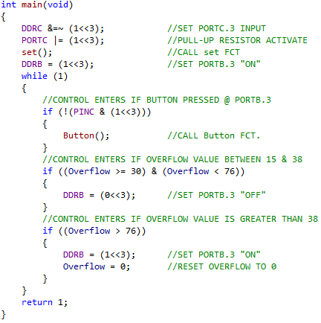

1. **DEVELOPED MODIFIED CODE OF TASK 2/A from TASK 1/A**

N/A

1. **SCHEMATICS**

N/A

1. **SCREENSHOTS OF EACH TASK OUTPUT (ATMEL STUDIO OUTPUT)**

Logic Analyzer for 250ms

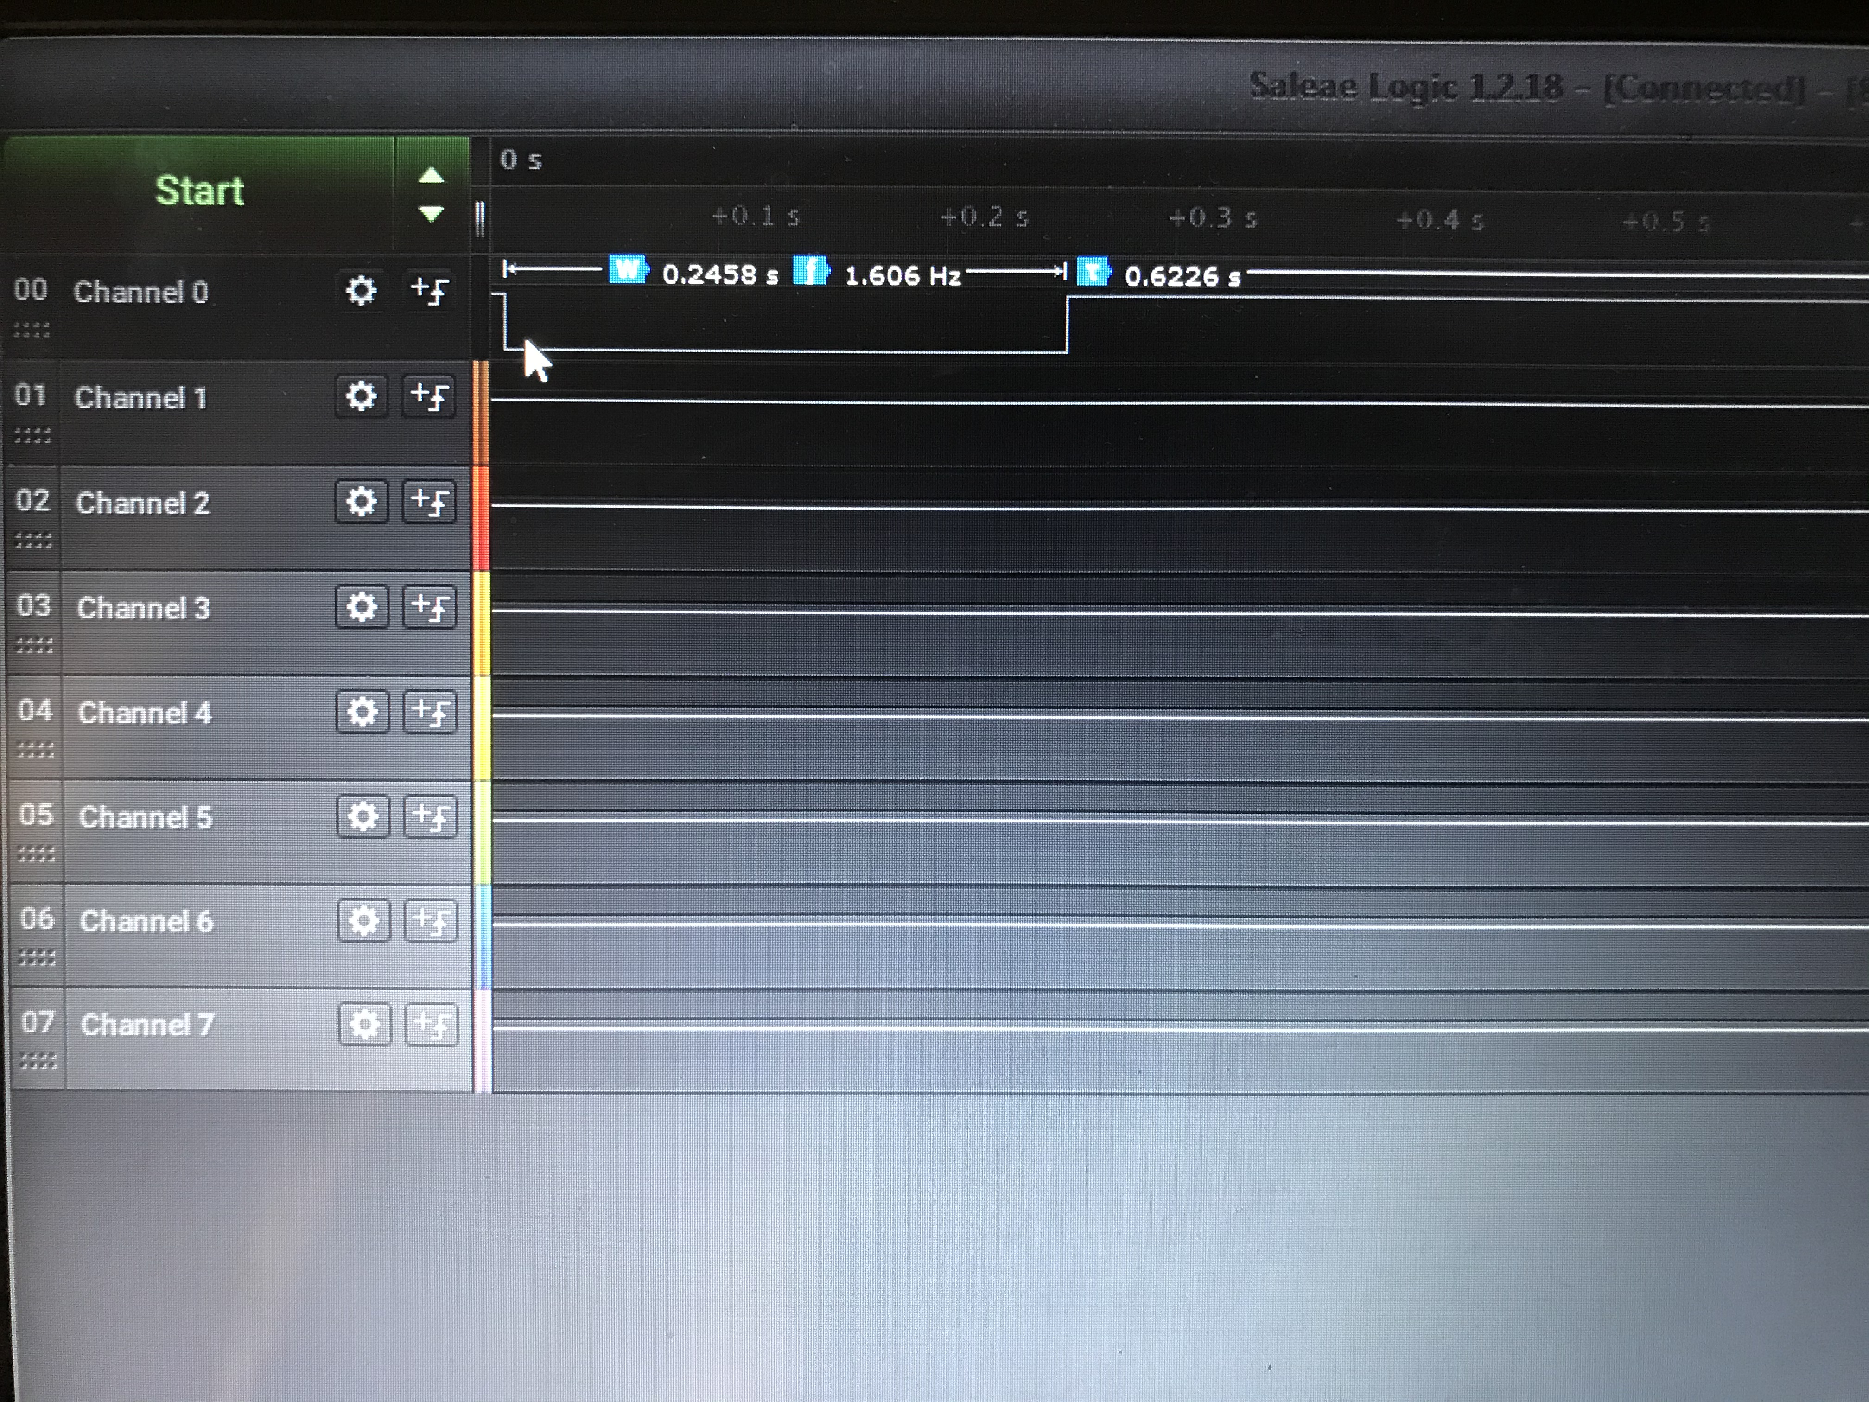

Logic Analyzer for 375ms

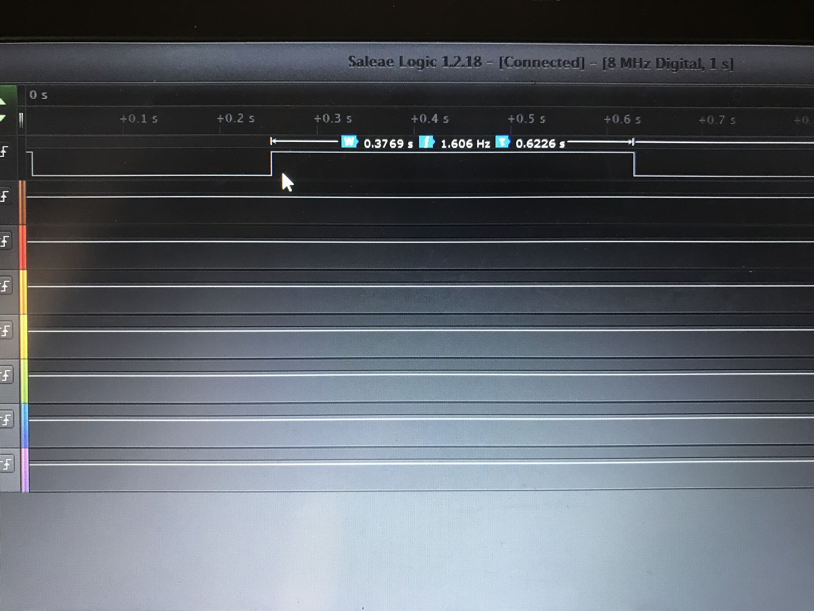

1. **SCREENSHOT OF EACH DEMO (BOARD SETUP)**

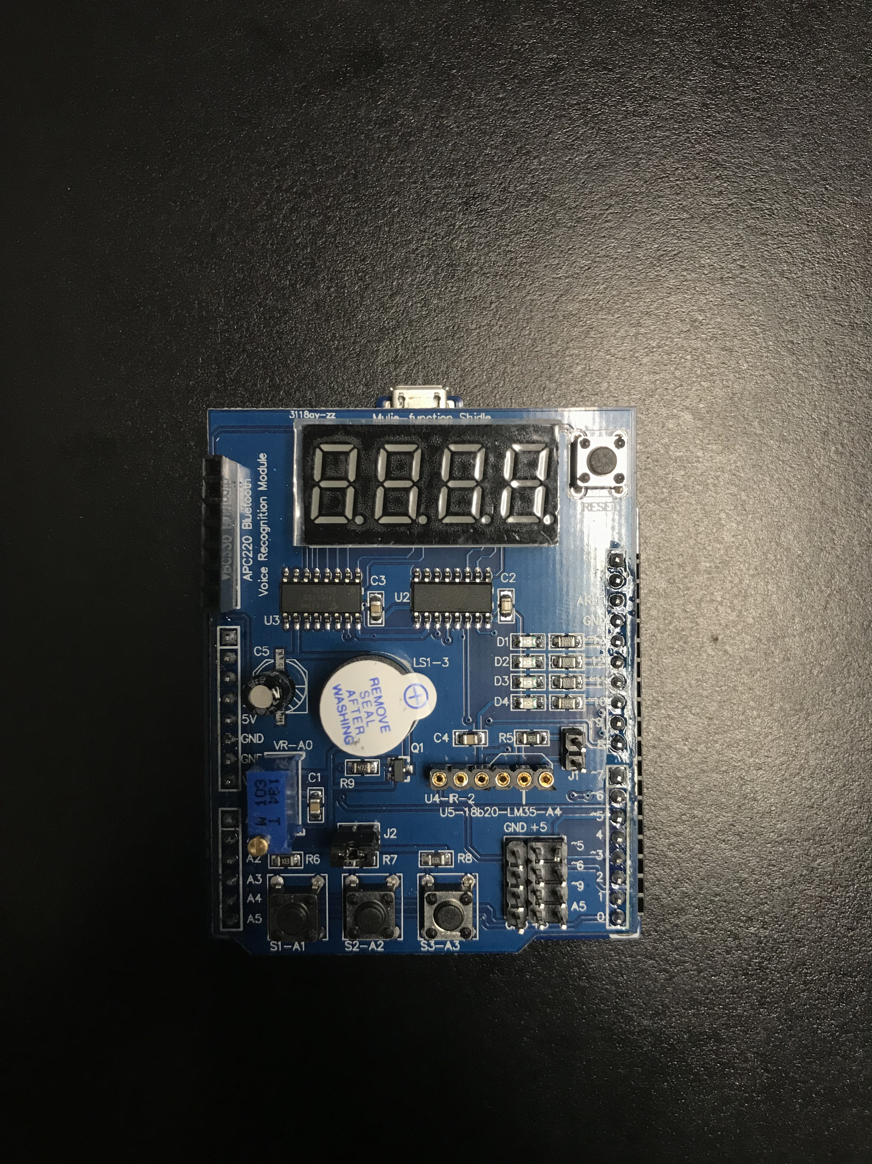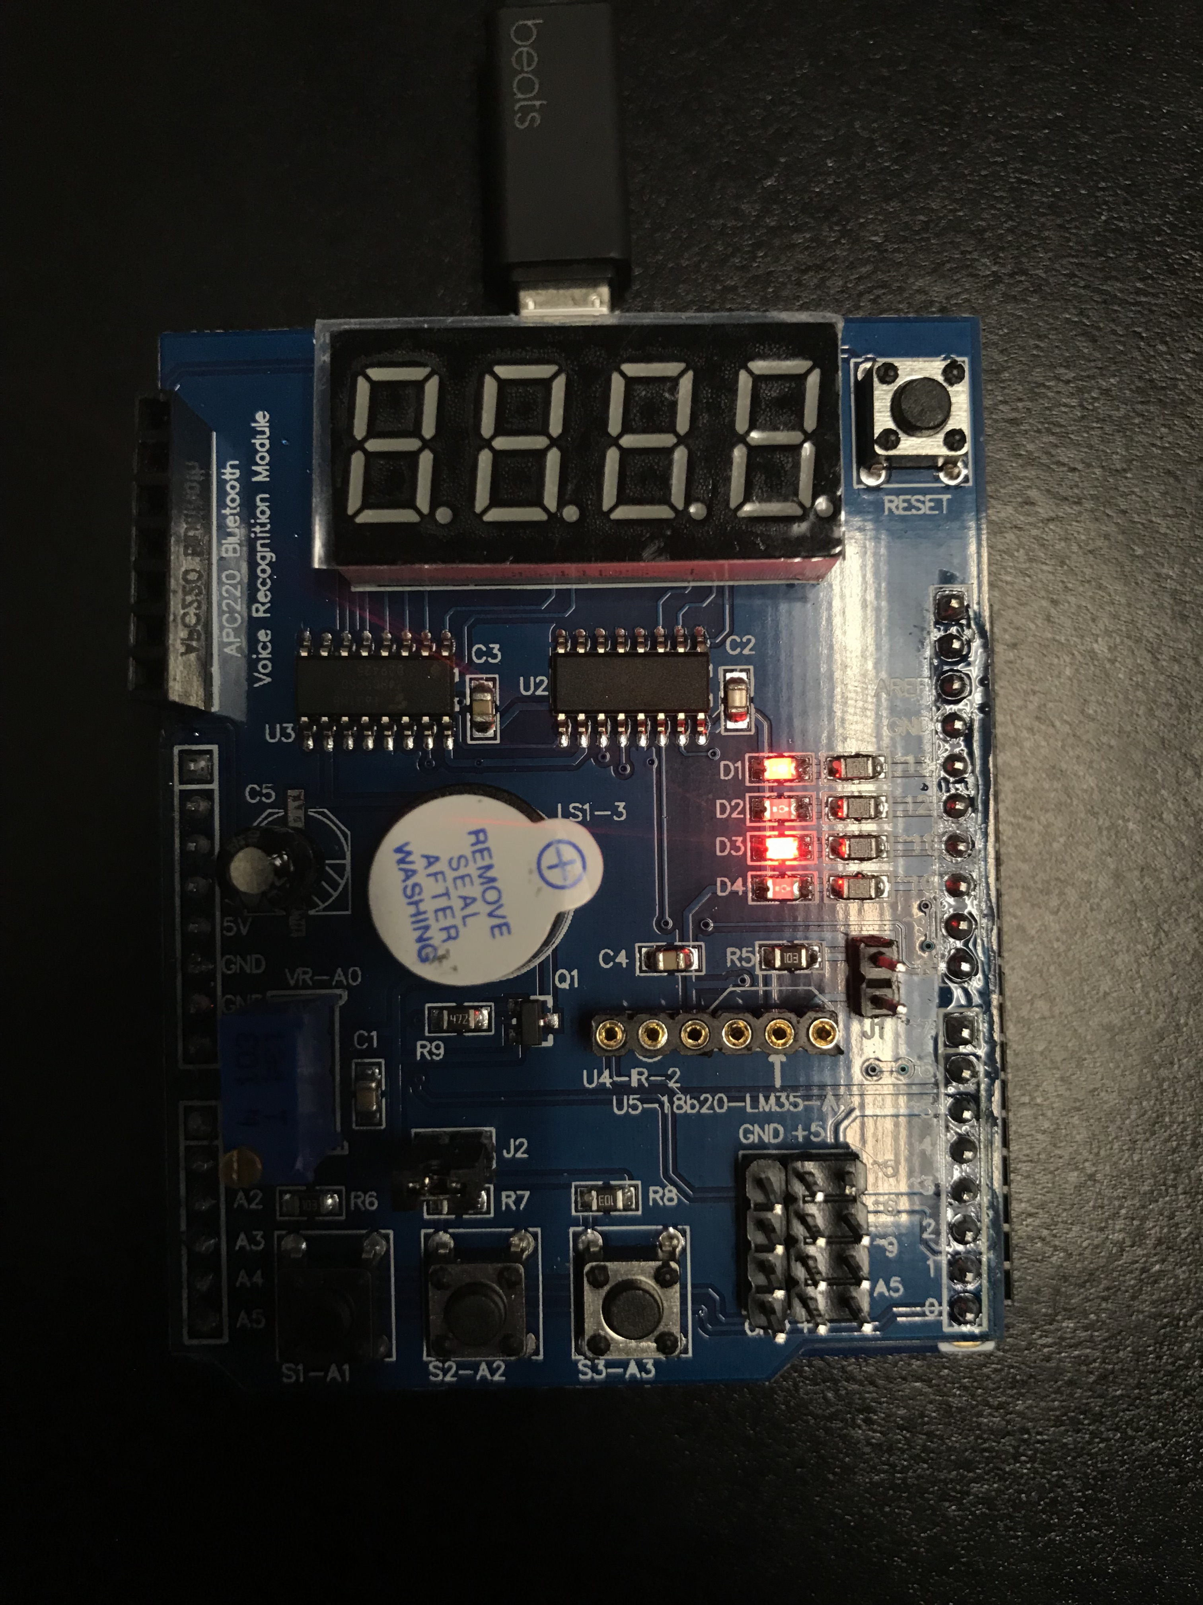

1. **VIDEO LINKS OF EACH DEMO**

Task1

<https://youtu.be/028m5LZt_Yw>

Task2

<https://youtu.be/8ASNDw0QUcE>

Task3

<https://youtu.be/AWF-g9BlYB0>

1. **GITHUB LINK OF THIS DA**

<https://github.com/bkokubun99/Submission_DesignAssignments/tree/master/DesignAssignment_2C>

**Student Academic Misconduct Policy**

<http://studentconduct.unlv.edu/misconduct/policy.html>

“This assignment submission is my own, original work”.

Brysen Kokubun